# Stressor: Fine Sediment (%)

# Species: Coho Salmon

# Life Stage/Season: Fry/Parr Rearing

## Citation

## *Beechie, T. J., C. Nicol, C. Fogel, J. Jorgensen, J. Thompson, G. Seixas, J. Chamberlin, J. Hall, B. Timpane-Padgham, P. Kiffney, S. Kubo, and J. Keaton. 2021. Modeling Effects of Habitat Change and Restoration Alternatives on Salmon in the Chehalis River Basin Using a Salmonid Life-Cycle Model. U.S. Department of Commerce, NOAA Contract Report NMFS-NWFSC-CR-2021-01.*

## Stressor-Response Relationship

### Rationale

### Jensen et al. (2009) summarized published values of incubation productivity (survivorship) for four salmonid species (Chinook, Coho, Chum, and Steelhead) and created a logistic regression function to relate percent fines in streams to incubation productivity. Jensen et al. (2009) presented data for all four salmonid species. However, there was significant overlap among species, and there appeared to be little justification for using different functional relationships for each species. Therefore, they applied the published β0 and β1 estimates to define a functional relationship (presented here) applicable to all four salmonid species. Sedimentation (% fines) is treated as a productivity multiplier. Egg survivorship decreases in locations with a high percentage of fines as the dominant substrate. Impact mechanisms unspecified but likely to occur include direct suffocation or barriers to fry emergence from spawning gravels. The percentage of fines in spawning substrates should (ideally) be estimated from field surveys, but a generic function is provided to produce a rough estimate of fines for unsurveyed areas based on road densities (estimates are expected to have limited transferability across systems).

### Function

Derived relationship between fry/parr rearing habitat (density-independent incubation productivity in redds) and generalized % fine sediment in spawning gravels. The % fine sediment in spawning gravels is predicted by road density for areas with a slope to bankfull width index > 0.05; where it is assumed that areas with a slope to bankfull width index < 0.05 have very high fine sediment levels which aren’t significantly influenced by road density (Beechie et al., 2021; data from Mobrand Biometrics, Inc. 2003).

#### **Type:**

Empirical (Real data)

#### **Original Function:**

Where slope to bankfull width index is > 0.05:

$$fine sed = 5.74+2.05*road density$$

$$p_{incub} =\frac{ 1}{1+e^{-1.989+0.185*fine sed}}$$

*fine sed* is the percent fine sediment <0.85mm.

*road density* is the hectares of current roads per hectare of drainage area.

*pincub* is incubation productivity from 0-1. This is then scaled to 0-100% to represent mean system capacity (%). An offset of +12% is added to standardize the function such that the maximum value is 100%.

## Known Covariates or Stressor Interactions

### Covariate(s)

Applicable for areas with a slope to bankfull width index > 0.05. The slope to bankfull width index calculated as bankfull width times reach slope (rise/run).

### Interaction Type

Threshold

## Considerations

See rubric in Appendix A for explanations of the data classifiers below.

Data Source: Mechanistic (theory based), and empirical relationship from Jensen (2009) between road density and fines.

Data Type: Empirical relationship

Data Quality: Strong relationship between fine sediment (%) and incubation productivity; however, very weak correlation between fine sediment and road density. Field estimates of fine sediment are recommended rather than GIS proxies.

Confidence in SR function: Moderate uncertainty

### Notes and User Recommendations

Jensen et al. (2009) note that data availability may constrain the accuracy and applicability of the SR results. Few studies were available to develop the SR curve, and most of those studies were based on controlled laboratory data.

**______________________________________________________________________________**

## Stressor-Response Curve

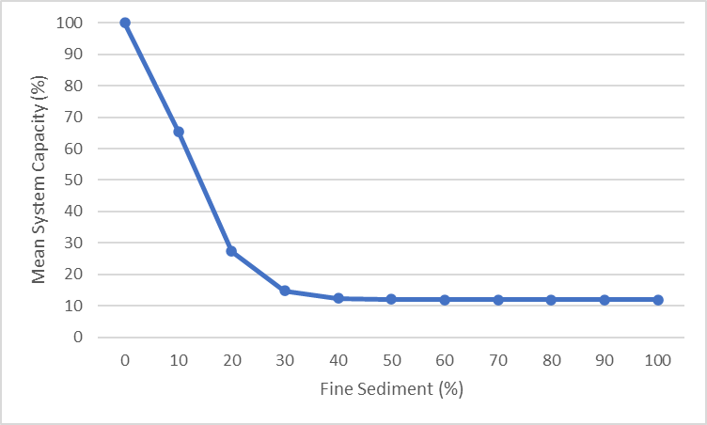

**Figure 1:** Stressor-response relationship between percent fine sediment and incubation productivity (0-1), interpreted as system capacity in the model. Data are from Beechie et al. (2021).

## Stressor-Response Table

**Table 1:** Discrete stressor-response relationship between raw stressor values and the mean system capacity (0-100%; scaled incubation productivity). The standard deviation of the mean system capacity is defined by the user and represents the inherent stochasticity or noise in the relationship. The set lower limit and upper limit of the mean system capacity are also presented. Mean system capacity (0-100%) is a standardized measure of wild adult recruits produced by the previous spawner cohort.

|  |  |  |  |  |
| --- | --- | --- | --- | --- |
| **Sediment** | **Mean System Capacity (%)** | **SD** | **Lower Limit** | **Upper Limit** |
| 0 | 100 | 0 | 0 | 100 |
| 10 | 65.46941575 | 0 | 0 | 100 |
| 20 | 27.30340562 | 0 | 0 | 100 |
| 30 | 14.76255473 | 0 | 0 | 100 |
| 40 | 12.44473039 | 0 | 0 | 100 |
| 50 | 12.07019123 | 0 | 0 | 100 |
| 60 | 12.0110432 | 0 | 0 | 100 |
| 70 | 12.00173656 | 0 | 0 | 100 |
| 80 | 12.00027306 | 0 | 0 | 100 |
| 90 | 12.00004293 | 0 | 0 | 100 |
| 100 | 12.00000675 | 0 | 0 | 100 |

## Additional References

Jensen, D. W., E. A. Steel, A. H. Fullerton, and G. R. Pess. 2009. Impact of fine sediment on incubation survival of Pacific salmon: a meta-analysis of published studies. Reviews in Fisheries Science 17(3):348-359.

Mobrand Biometrics, Inc. 2003. Assessment of Salmon and Steelhead Performance in the Chehalis River Basin in Relation to Habitat Conditions and Strategic Priorities for Conservation and Recovery Actions. Mobrand Biometrics, Inc. Vashon, WA.